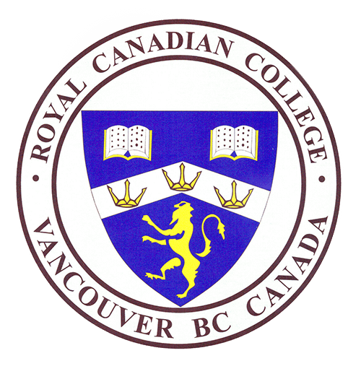 Royal Canadian College
8610 Ash Street, Vancouver, British Columbia, Canada V6P 3M2
Telephone : (604) 738-2221 Fax : (604) 738-2282
E-Mail : info@royalcanadiancollege.com Website : www.royalcanadiancollege.com

Royal Canadian College (a BC Ministry of Education certified Independent Secondary School) now hiring a: ENGLISH AND SOCIAL STUDIES (HUMANITIES) TEACHER

Qualifications - Documented evidence of:
- B.C. Ministry of Education Teaching Certification

Job duties and skills:
- Primarily teaching English and Social Studies to High School students
- May also be called on to teach additional courses
- Ability to teach in a multi-cultural environment an asset

Compensation: $50 - $55 per hour
Start Date: June 17, 2019
Employment Type: Full-time, contract (This is a non-profit organization)
FTE: 1.00
Closing Date: May 27, 2019
Apply in writing to: info@royalcanadiancollege.com with a cover letter, and an updated resume and supporting documentation that will ensure qualifications are met or exceeded for this position.

